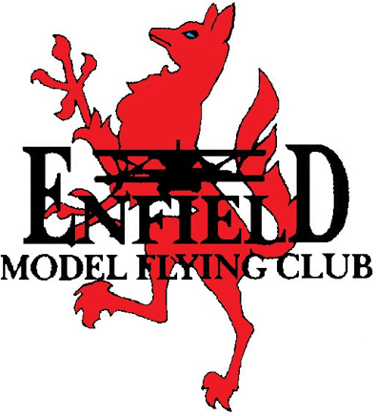
Enfield Model Flying Club
MEMBERSHIP APPLICATION 2025

APPLICANTS DETAILS

Surname ………………………...……………………………………..

Forenames

Address

Post code

Telephone E-mail address

Other clubs you are or have been a member of

Existing BMFA membership no. (If any)
Flying interests (Please tick)
I.C. Electric Drones Planes Gliders Helis

Experience (Please tick)

Beginner BMFA ‘A’ Cert BMFA ‘B’ Cert Other …….………....

Membership fees

Please note a £5 early-bird discount is available if paid before 31/12/24.

Club Fees (please tick one)

Senior: £40 (Including Chingford Permit) Senior: £35 (Excluding Chingford Permit)

Junior: £20 (Including Chingford Permit) Junior: £15 (Excluding Chingford Permit)

BMFA (Includes insurance) (Please tick one)

Senior: £49

Junior: £20 (under 18 years)

You cannot fly until you are in possession of a permit (Chingford) and insurance which must be carried at all times when flying. Failure to do so could incur a fine from the London Corporation.
Please note, at present club meetings are held remotely via invite over a “teams” format at 8pm on the 3rd Wednesday of the month (not December).

I WISH TO APPLY FOR MEMBERSHIP OF THE ENFIELD MODEL FLYING CLUB AND IF
ACcEPTED AGREE TO ABIDE BY THE RULES AND Majority Decision oF THE CLUB

Signature Date
Please forward completed form to Membership Sec. Tony Willson Tel. 07714 067252
Either by post, email or WhatsApp. 5 The Rickyard, email:
Haddenham, Ely, afw@btinternet.com
Cambs, CB6 3UR

